Problem Set 4
(100 points)

AI tools policy for problem sets: For problem sets, you may use AI tools (e.g. ChatGPT) to help brainstorm or to revise existing work you have written. When you submit your problem set, we expect you to clearly attribute what text was generated by the AI tool (e.g., AI-generated text appears in a different colored font, quoted directly in the text, or use an in-text parenthetical citation). While AI tools can provide helpful insights, we want you to think critically about the information you receive. We encourage you to ask specific questions, provide context, and evaluate the quality of the answers provided by AI tools. Remember, the answers are not always correct.

Problem 1. Maguire Alarm Company (25 points)
The Maguire Alarm Company is a medium-sized electronics company specializing in alarm devices. Maquire's demand function is estimated as Q = 4500 - P. The company has the following cost function: TC = 150,000 + 400Q. Suppose that the current sales price is $2,000 per unit.

a. (4 points) What is the current level of profits at this price?

b. (4 points) What is the own-price elasticity at the current price of $2,000? Is demand elastic or inelastic at this price?

c. (12 points) What is the optimal quantity and price (at which profits are maximized)? What is the level of profits at this optimal price? What is the own-price elasticity of demand at this optimal price? Is demand elastic or inelastic at this price?

d. (5 points) What is the share of markup in the optimal price (Lerner Index)? Show the two ways of computing the Lerner Index by relating it to the demand elasticity estimated in c.)

Problem 2. Dayna’s Doorstops (From Pindyck and Rubinfeld, 20 points)

Dayna’s Doorstops, Inc. (DD) is a monopolist in the doorstop industry.
Its total cost is TC = 100 – 5Q + Q², and (inverse) demand is P = 55 – 2Q.

- (5 points) What price should DD set to maximize profit? What output does the firm produce? How much profit does DD generate?

- (7 points) What would output be if DD acted like a perfect competitor and set MC = P? How much profit would DD generate?

- (8 points) Show graphically the consumer surplus and producer surplus under perfect competition (part b.). Then draw a separate graph showing consumer and producer surplus under monopoly (part a). Illustrate on the second graph the deadweight loss due to monopoly. Explain in words the consequences of having a monopoly instead of perfect competition on consumer surplus, producer surplus, and on total welfare. Note: You do not need to plot the exact functions from a. and b.; an illustration is fine. You may use AI tools to produce graphs.

Problem 3. Reinventing Barnes & Noble (20 points)
James Daunt, the CEO of Barnes & Noble, was hired before the sales of Barnes & Noble reached the bottom. His goal is to change the business model of the company.

- (5 points) Describe how the market for books has changed since the early 2000s. What do you think are the reasons for the decline in the fortunes of Barnes & Noble?

- (5 points) Consider the following three demand curves: Which one represents the best approximation for the demand Barnes & Noble faces and why? Use the concepts learned in class to describe the characteristics of the market in which Barnes & Noble operates.

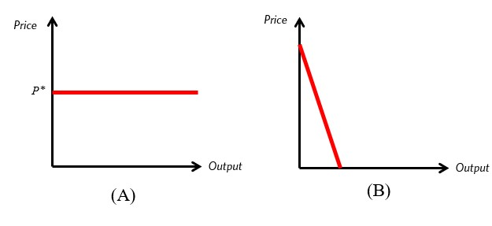
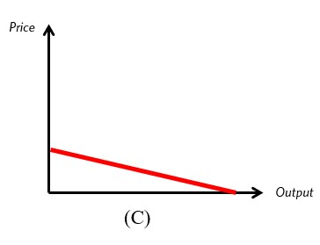

- (5 points) What does this type of demand curve imply about the ability of Barnes & Noble to increase the price of its products?

- (5 points) In a recent interview, James Daunt proposed to give more freedom to the individual bookstores: “You should do what you want; there are no restrictions on what books you stock…Each bookshop is quite individual.” Propose two strategies for bookstores to differentiate themselves from competitors. What does differentiation imply for the price elasticity of demand?

Here are two interesting podcasts you might consider listening to know more about the business strategy of Barnes & Noble.

https://www.theverge.com/23642104/barnes-and-noble-amazon-bookshop-ecommerce-decoder-podcast

https://www.npr.org/2023/03/07/1161295820/how-barnes-noble-turned-a-page-expanding-for-the-first-time-in-years

Problem 4. Avocado pricing strategy (20 points).

From 2015-2018, the demand for avocados (both conventional and organic) in Atlanta was:
$$Q_{A}=730-175P_{A}$$

Where quantity Q is in 1,000 per week and P_{A} is the average weekly price per avocado across all retailers.

For the same time period, the demand for avocados in San Diego was:
$$Q_{B}=855-319P_{B}$$
Again, Q is in 1,000 per week and the price is per avocado.
The marginal cost of production is the same in both markets and equal to $0.17 per avocado.

Note: The fact that Q is given in 1,000 units should not affect any of your calculations. You can use the formulas and marginal cost exactly as given above, without multiplying or dividing by 1,000. Only in the end, when you interpret total quantity, total revenues, or profits, note that all those will be in 1,000. For example, if you compute total revenues of $5,000 then those would actually correspond to $5,000,000. However, the price is given per unit. So if you compute an optimal price of $100 per unit, then that is your final result. You may use AI tools to produce graphs. Graphs don’t need to be to scale, they can be used merely for illustration.

- (5 points) What is the optimal price to charge in Atlanta? Show your work both analytically and graphically.

- (5 points) What is the optimal price to charge in San Diego? Show your work both analytically and graphically.

- (3 points) What is the own-price elasticity of demand at the profit-maximizing prices in the two cities?

- (4 points) Do your findings in a. and b. (price in each market) and in c. (own-price elasticity in each market) confirm what we learned in class about elasticities and price discrimination?

- (3 points) Explain which problems may result from the pricing structure that you have calculated in the previous questions. [A quantitative answer is not required. Hint: What if transportation costs are low relative to price differences?

Problem 5. Working Interactively with AI: The Future of Work (15 points)
Welcome to the AI & Labor Market Challenge.
In this exercise, you will collaborate with ChatGPT to explore how automation might reshape different occupations. Your task is to compute an index of exposure to AI for different jobs. This is the first index discussed in this podcast. You will use, interpret (and may also challenge) ChatGPT’s classification. Here are the step-by-step instructions.

Step 1 (2 points) — Choosing the Occupations
Go to the O*NET website (see print below) and identify two occupations from your team that are as different from each other as possible. The goal is to compare jobs that rely on different skills and tasks.
Note: If all team members have similar roles (for example, various types of managers), select one previous occupation or choose from this list: economist, lawyer, accountant, waiter/waitress, plumber, actor/actress, high-school teacher.

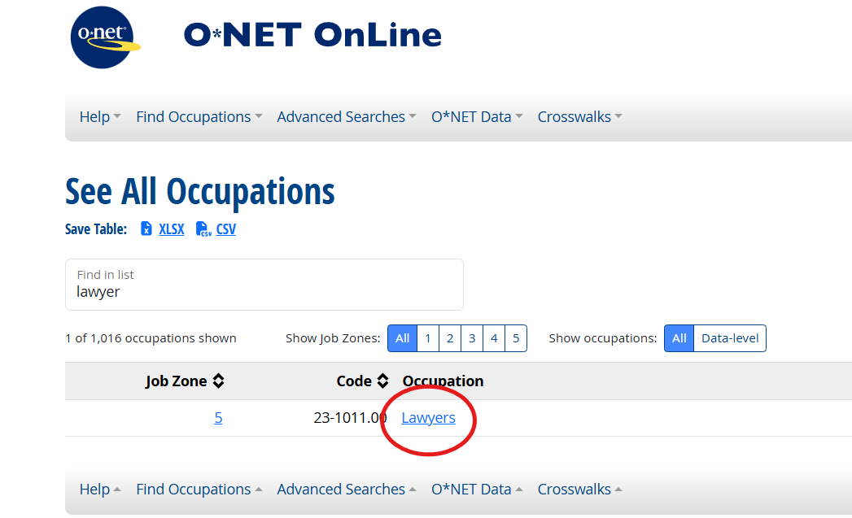

Step 2 (5 points) — Listing and Classifying Tasks
For each of the two chosen occupations, open the “Details → Tasks” tab in O*NET (see print below). Copy all core tasks for that occupation (supplemental tasks not required), together with their importance scores (0–100), into an Excel spreadsheet.
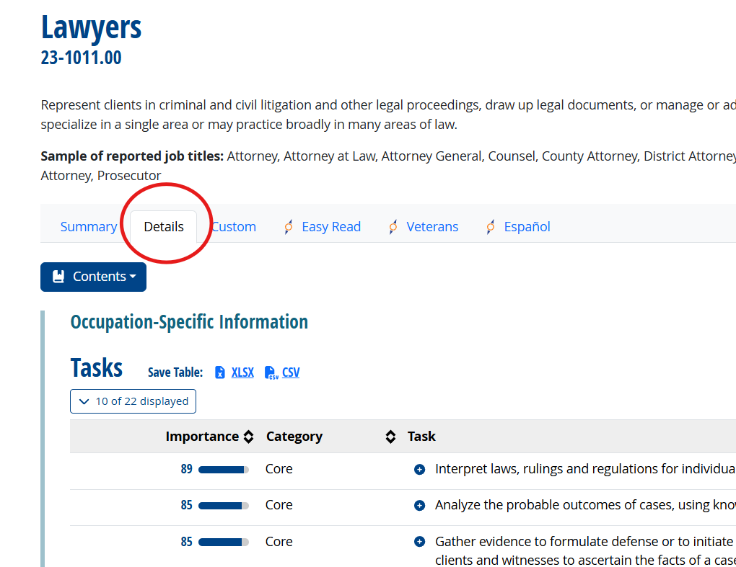
Paste this spreadsheet into ChatGPT (or any AI interface) and ask it to:

- Replacement dummy: Classify for each profession which task ChatGPT believes will be replaced by AI-supported automation in the next five years. Hint: Ask ChatGPT to add a new column “Replacement dummy” of 1s and 0s, where 1 indicates that the task will be replaced. Note: If you want to compute a more finely-grained index, you could also ask ChatGPT to classify the extent to which each task will be replaced with 0 indicating “none”, 0.25 indicating “some replacement”, 0.5 “substantial replacement”, 0.75 “almost completely replaced” and 1 “completely replaced”. But you will receive full credit also for the simpler 0/1 dummy.
- Review ChatGPT’s classification. You may change its coding if you disagree. Report your final table with scores in your solutions. Note: You do not need to document those steps. The idea here is that you create an AI-supported coding of tasks, supported by your own judgment. Of course, you can ask ChatGPT for its reasoning behind each coding.

Step 3 (8 points) — Computing the AI-Replacement Index
For each of the two occupations, compute an AI-Replacement Index using the importance score of each task as a weight:

AI Replacement Index = $Σ(Importance × Replacement dummy) / Σ(Importance)$,

where $\text{Σ}$ indicates “sum”.

Note: You may compute this in Excel, or you can ask ChatGPT to do the calculation. If AI Replacement Index = 1, then every single task of an occupation is replaceable by AI. On the other hand, a value of 0 implies that the occupation should be relatively “safe” from AI.

Compare the indexes for the two occupations.
Which occupation appears more exposed to automation? Do you agree or disagree with this result? Discuss briefly.

